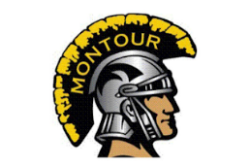
Montour Football Booster Meeting Agenda

October 1, 2019

Call Meeting to Order – Craig Sonson

Review Previous Meeting Minutes – Brandi Flint

Financial Report – Dana McGarry

Coach's Report - Lou Cerro
- Season Update

New Business
- Concession stand update
- Concession stand help / assignments
- Senior Night / Purple Game

Open For Questions, Ideas, and Concerns

Meeting Adjourned: Craig Sonson

Next Meeting 11/5/19

